Dalton Murray, Norhan John

Systems Analysis and Design

INT 6123 – Systems Analysis and Design

Dr. Andrew Makar

November 27, 2023

**Case Study 3**

**Network Diagram (10 points)**

**The time tracking system needs to support desktop and mobile devices.**

**Draw a network diagram for a 3-tier web-based architecture that includes mobile, tablet and desktop clients**

PNG:

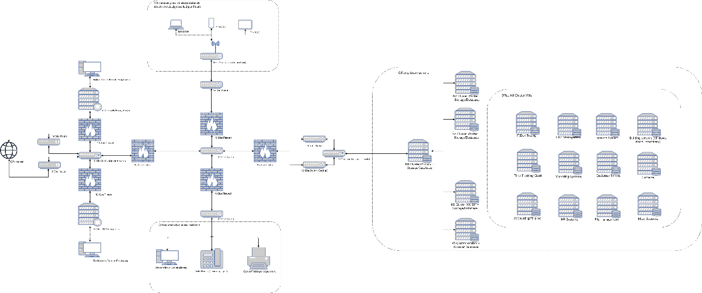

PDF: Attached separately

**Screen Design (25 points)**

1. **Login Screen**

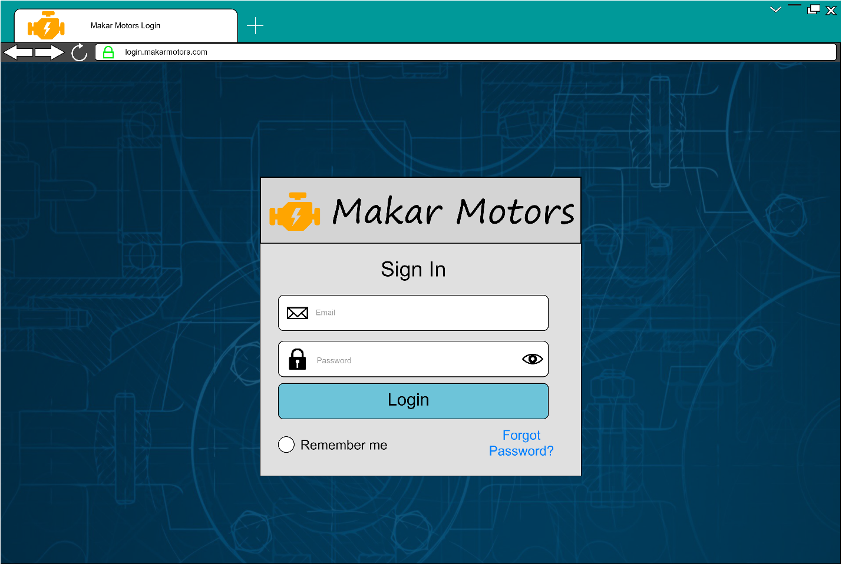

PDF: Attached separately

1. **Lost Password Screen**

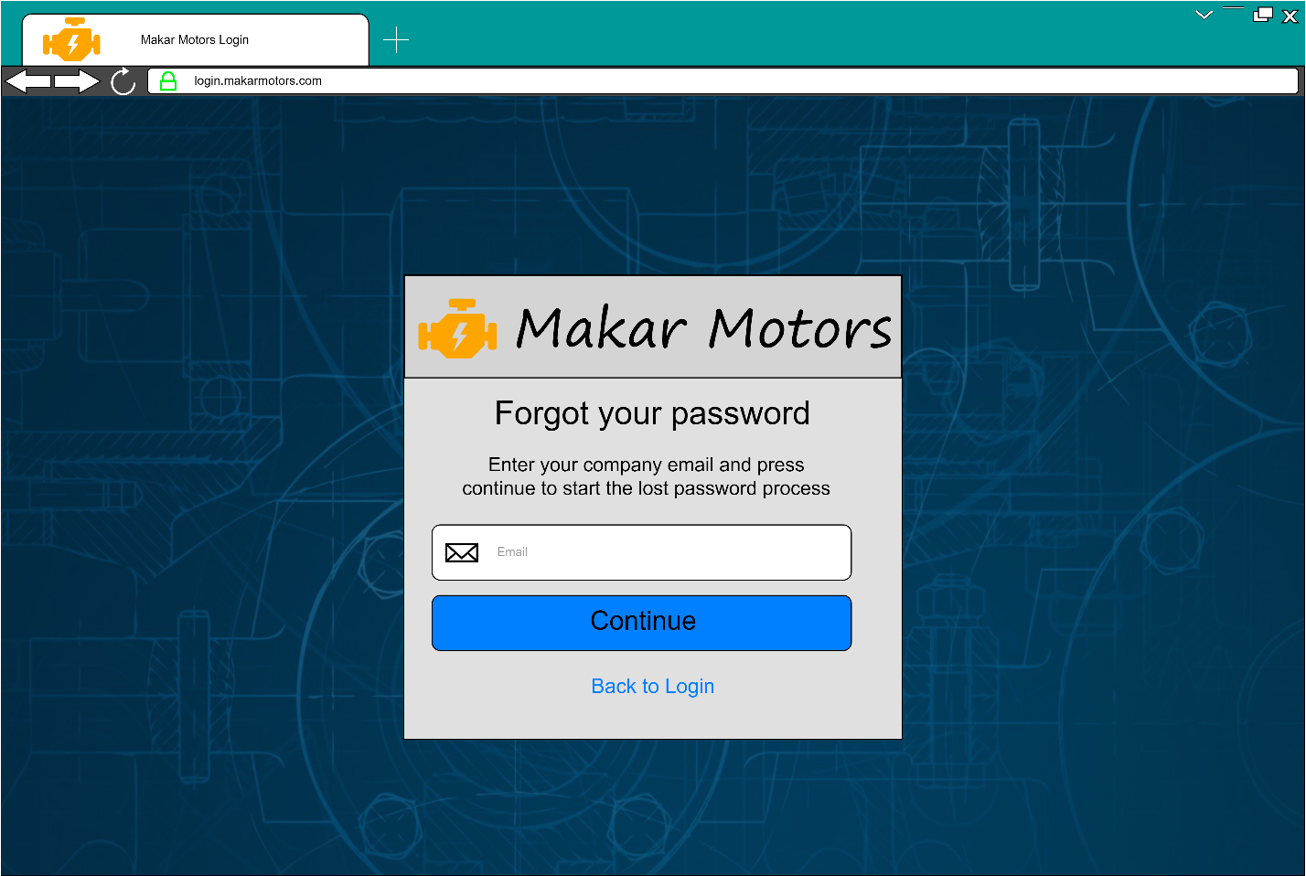

PDF: Attached separately

1. **Time Entry Form**

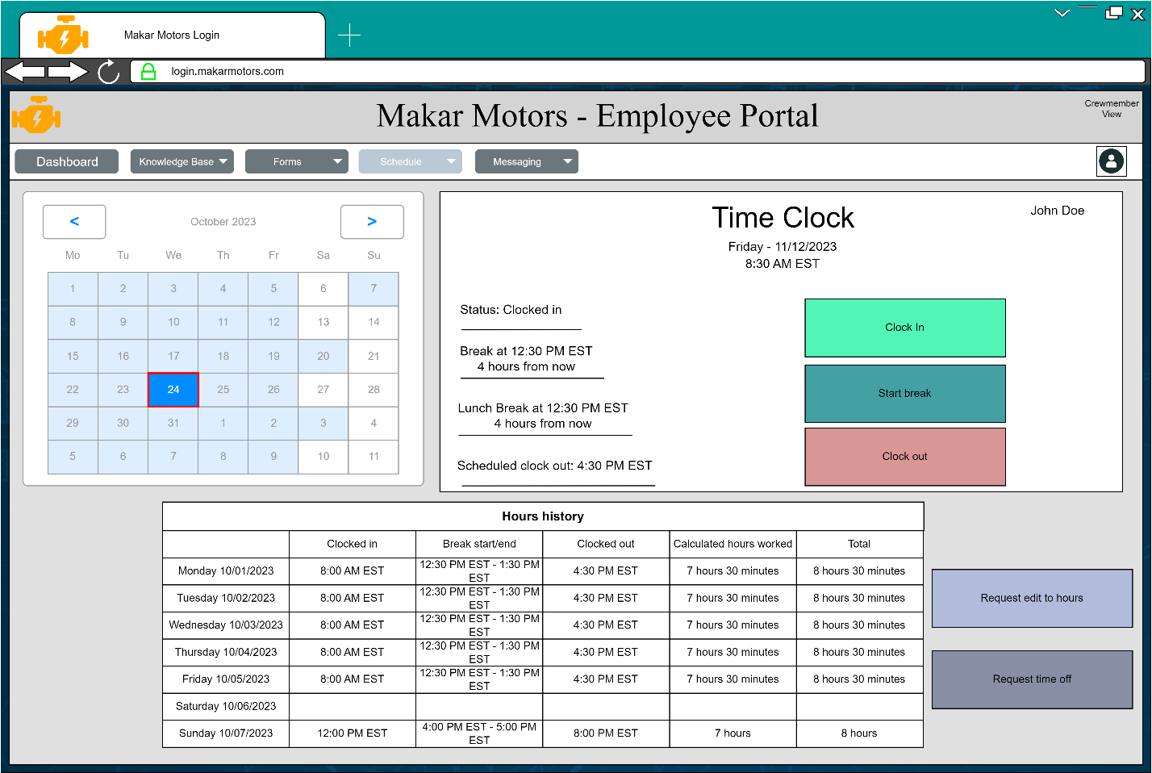

PDF: Attached separately

1. **Mass Time Approval Form & Mass Time Rejection Form**

(We have merged both mass time approval and rejection into one easy to use form)

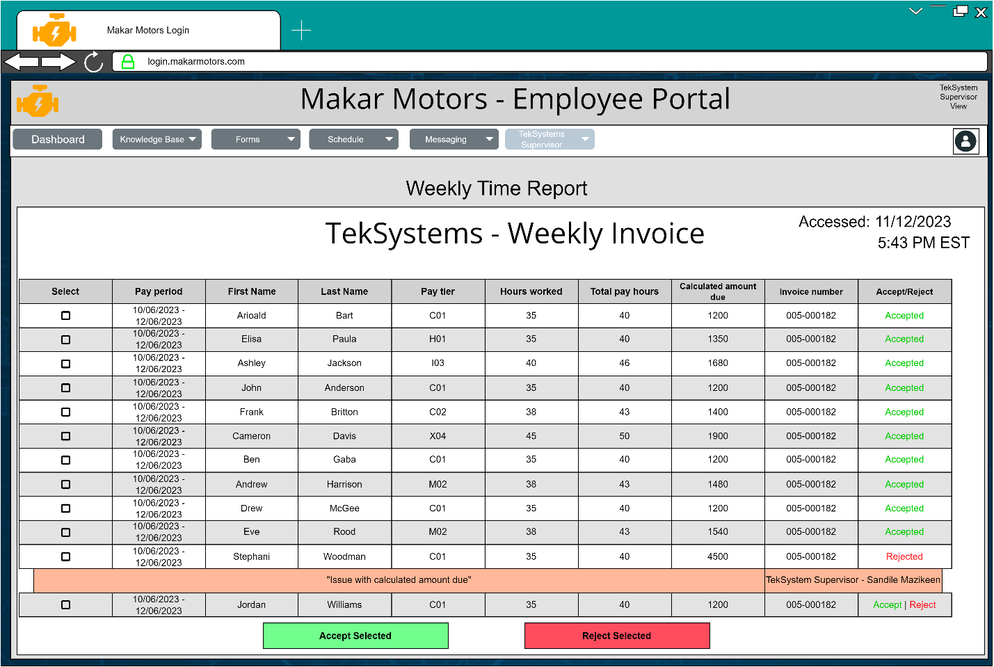

**Report Design (15 points)**

**Design the following reports and include sample data for each report.**

1. **Time Report by Individual**
2. **Time Report by Project**
3. **Vendor Invoice**

(We have merged all 3, time report by individual, time report by project, and vendor invoice into one report as it makes more logical sense to have them all work as one rather than have the 3 as separate reports)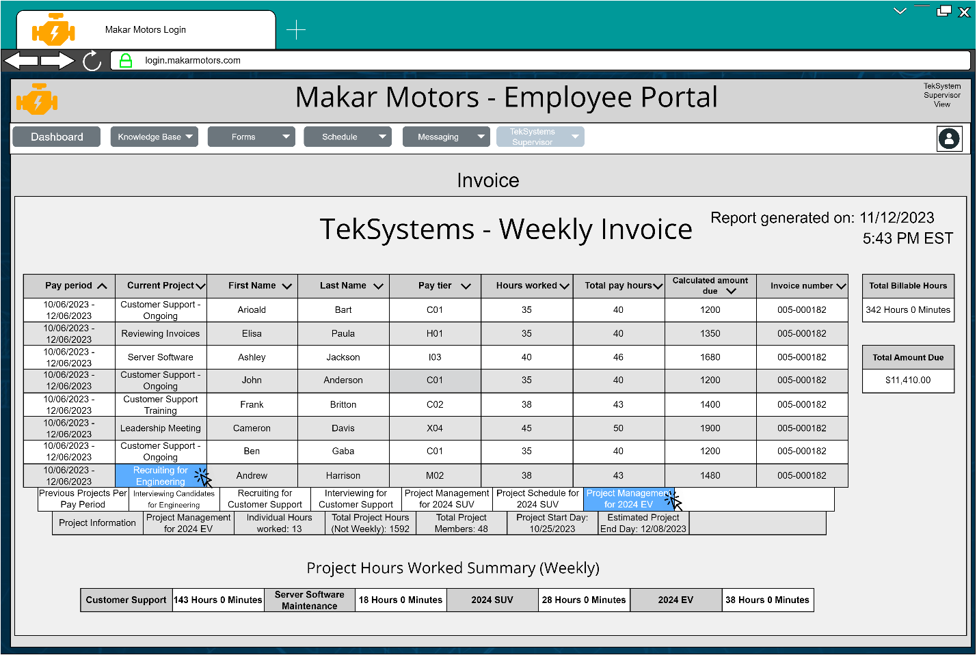  
Information such as Projects, Pay Tiers, Hours Worked, Total pay hours, calculated amount due are clickable to show more details about what exactly it is you clicked. For example, if you clicked on a current project of someone it will list all of the projects which they worked on in that pay period, you can then click on that project to show more details about that project. This allows for us to be able to contain all of the information in an easily accessible way so that we can get time reports by individuals, time reports by projects, and act as an overall invoice as it also shows general information such as total billable hours, total amount due, and how many hours have been spent on projects per a week.

**Database Design (25 points)**

1. **Refer to Class Diagram and create at least 5 sample tables in 3NF for database design.**
2. **Identify primary key with an underline.**
3. **Populate the table using Microsoft Access or Excel with 10 rows of sample data**

(*Example data randomly created/no actual persons data used, primary keys marked as golden key in structure section, and foreign keys marked as shaded key, also attached as .PDF, .CSV, and .SQL)

Data:

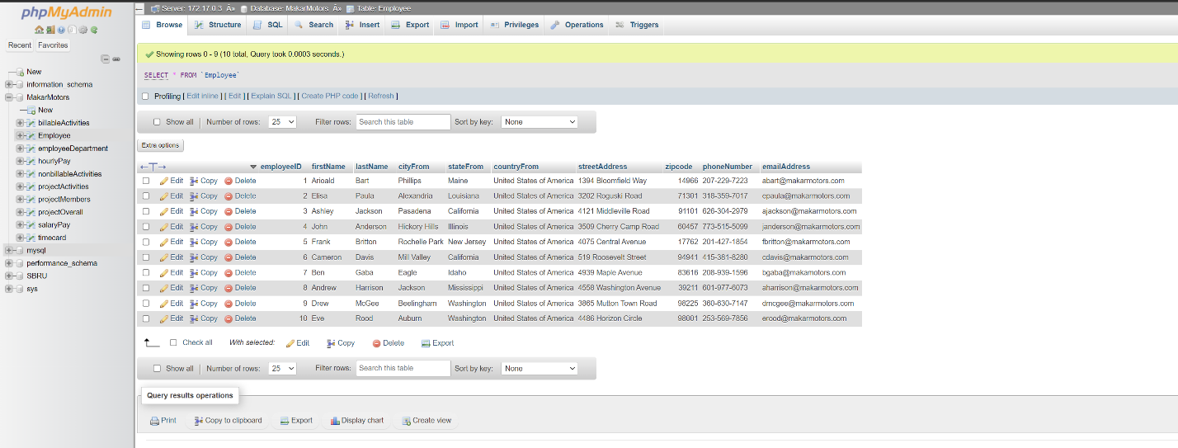

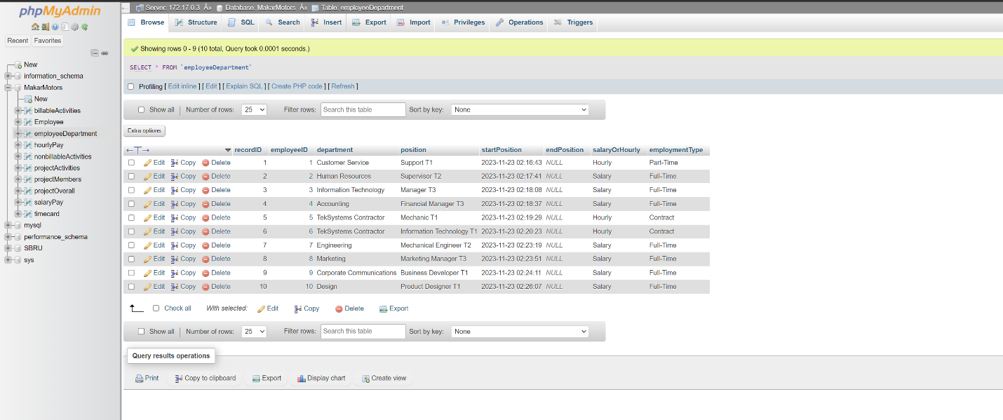

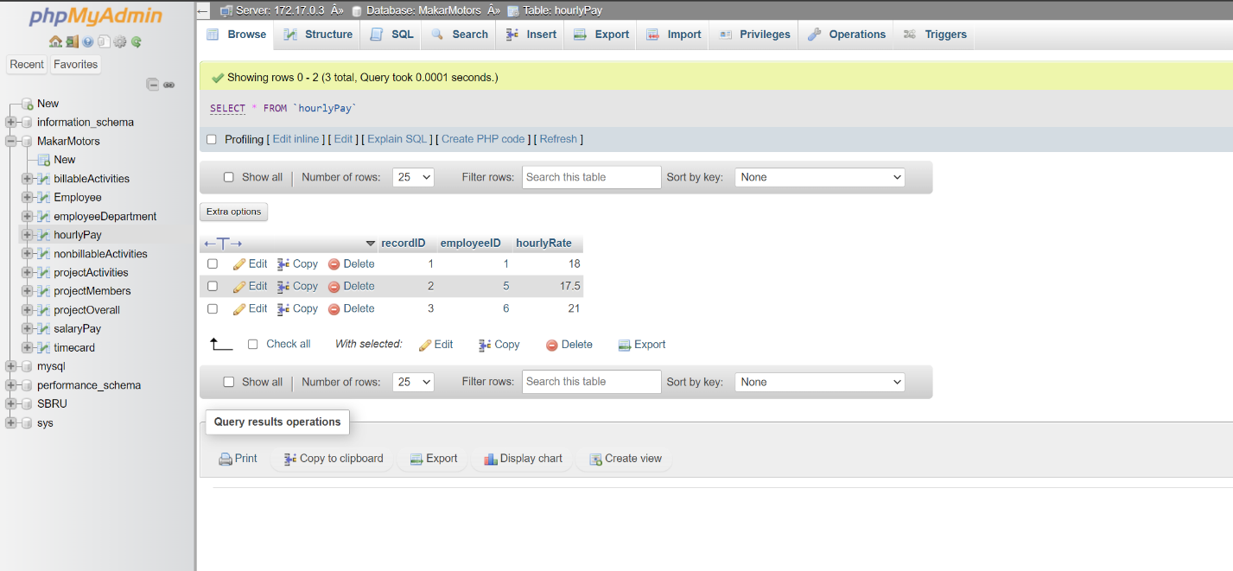

**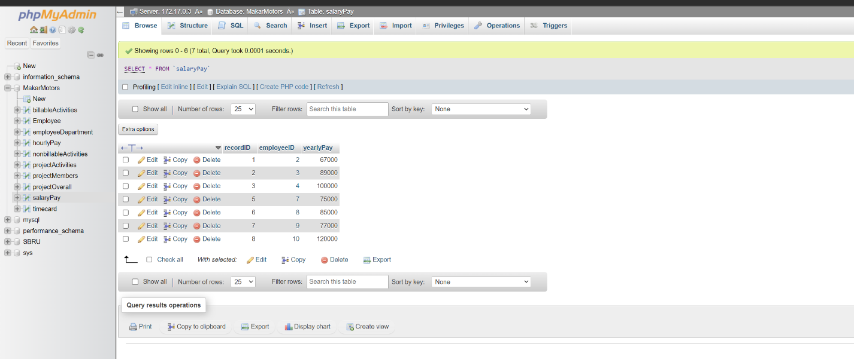  
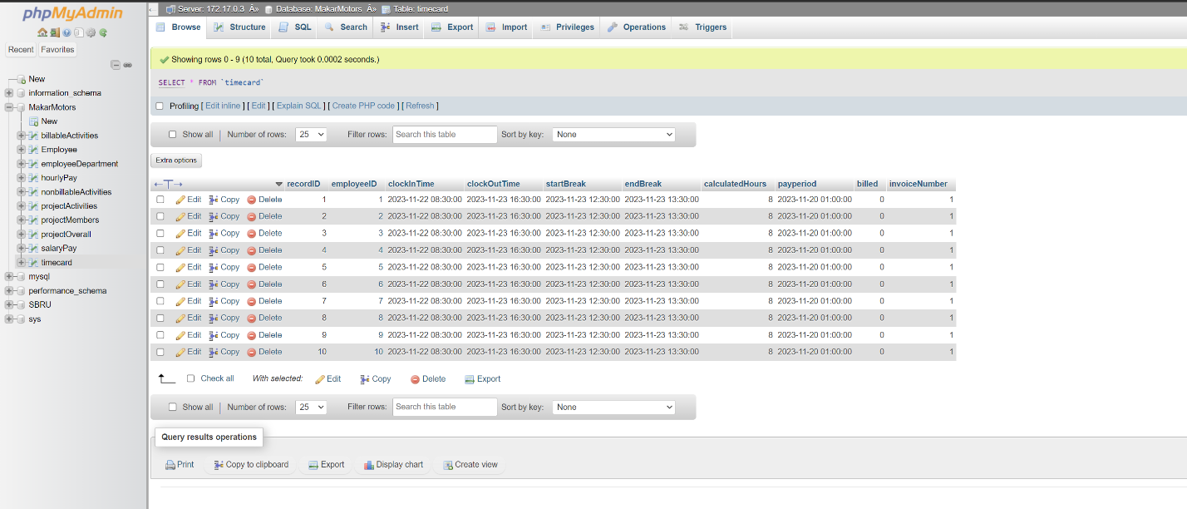**

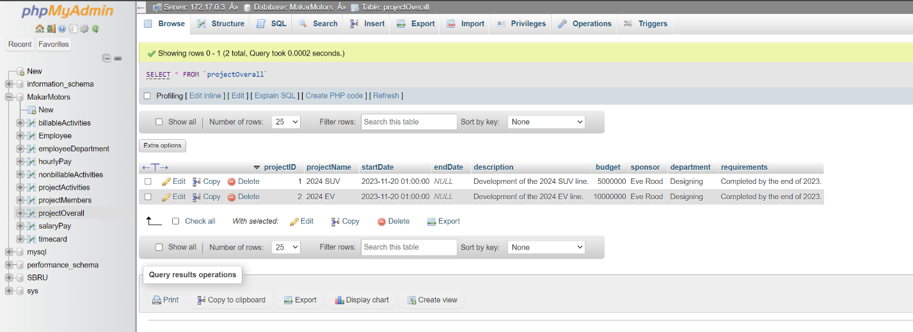

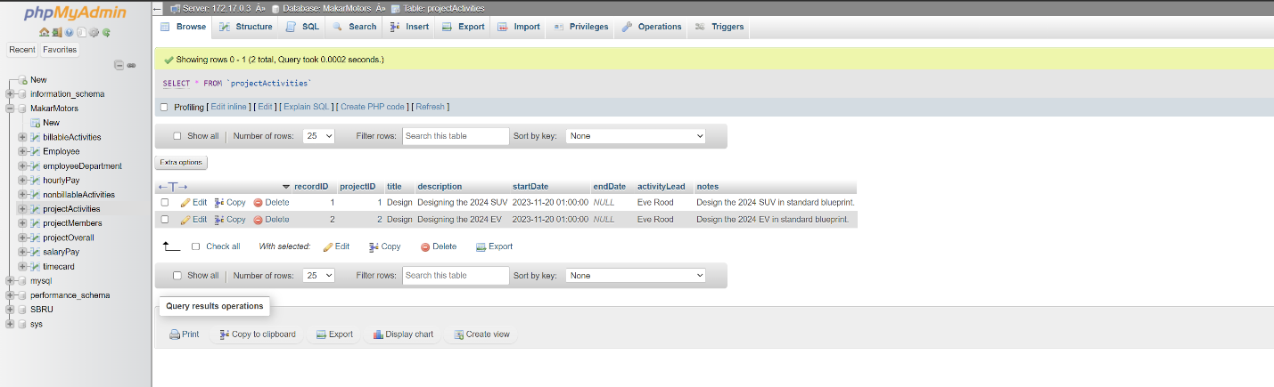

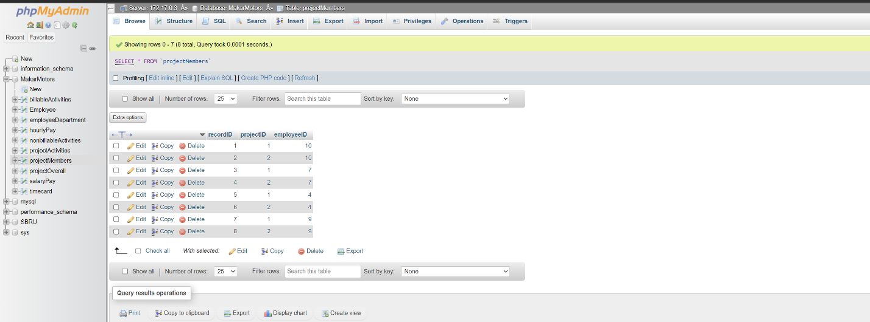

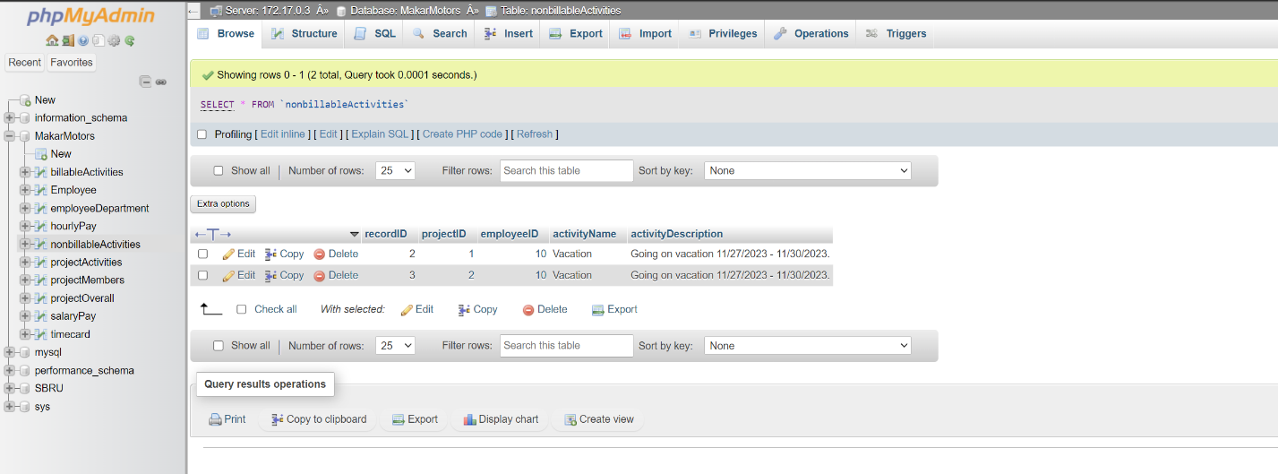

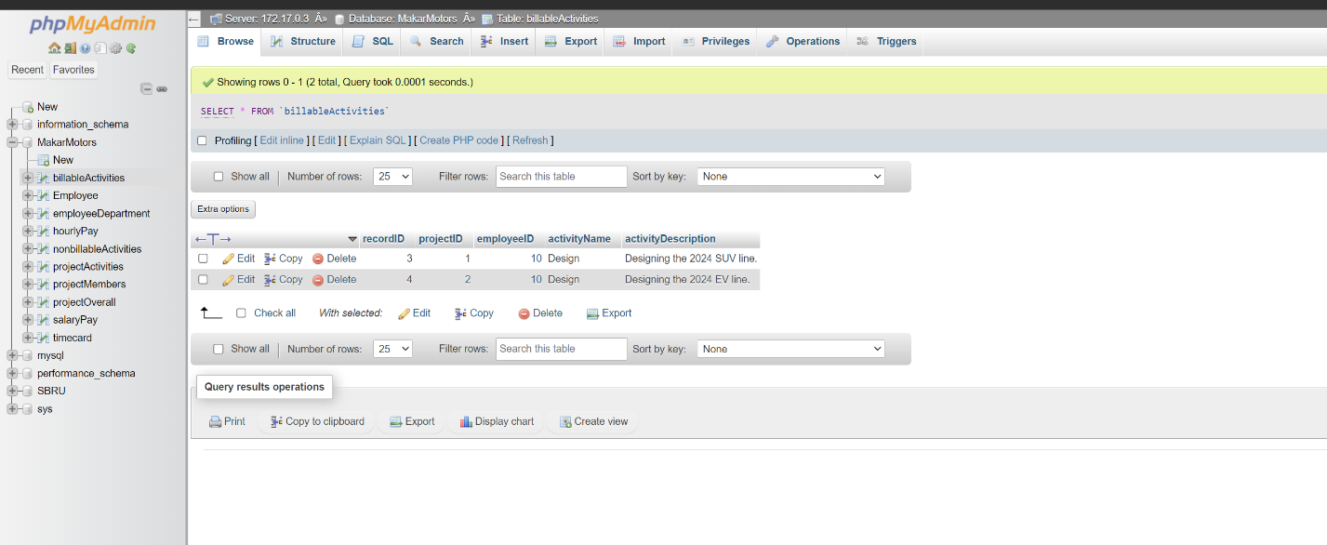

Structure:

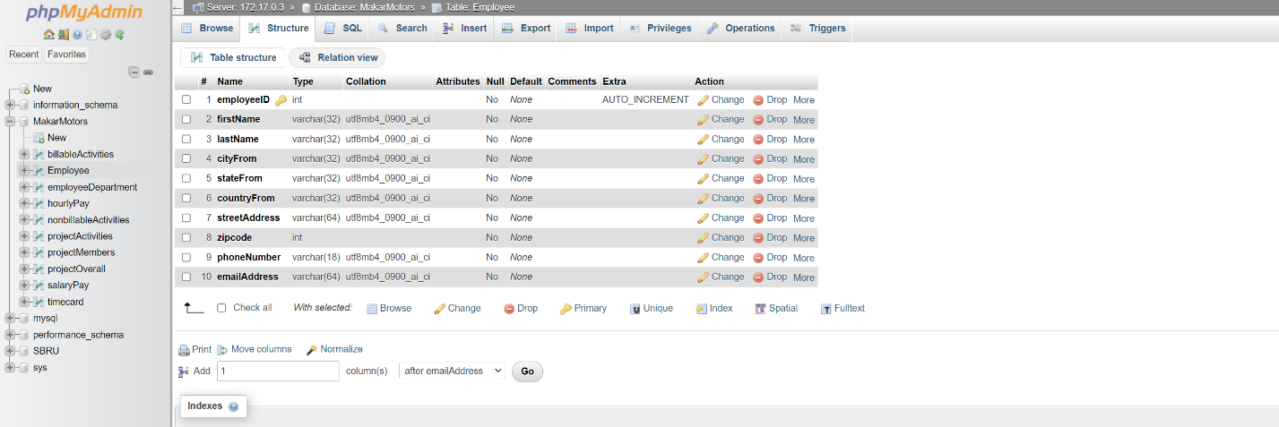

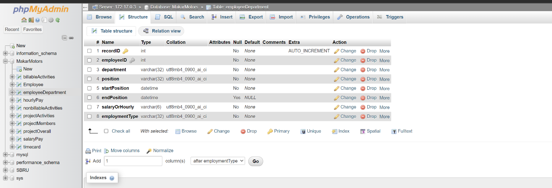

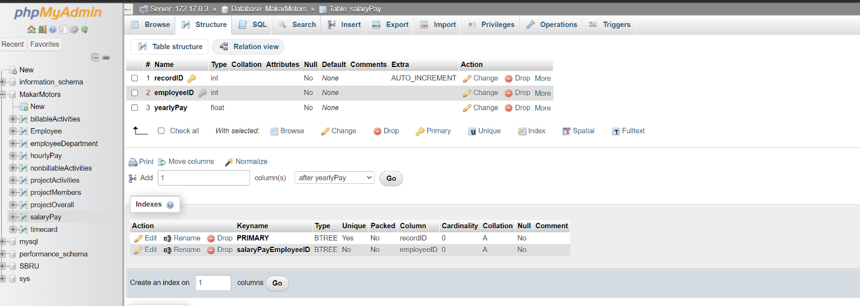

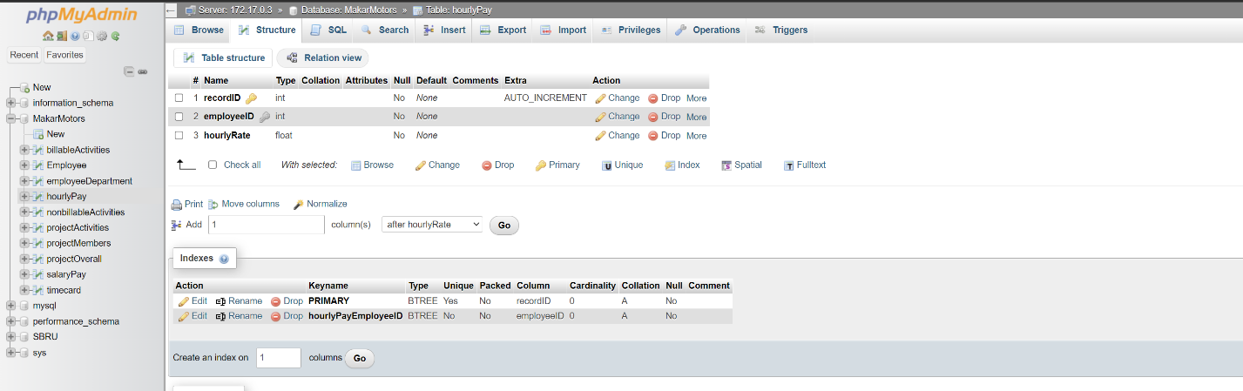

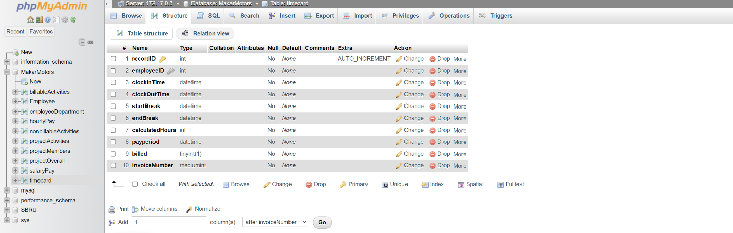

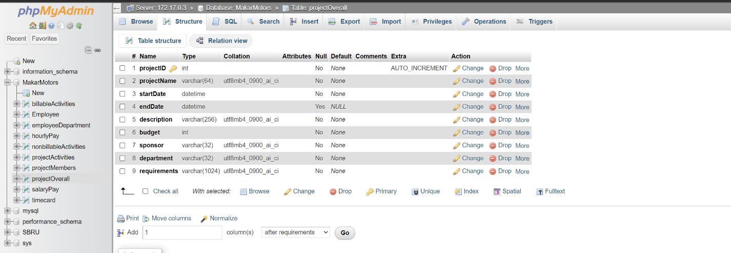

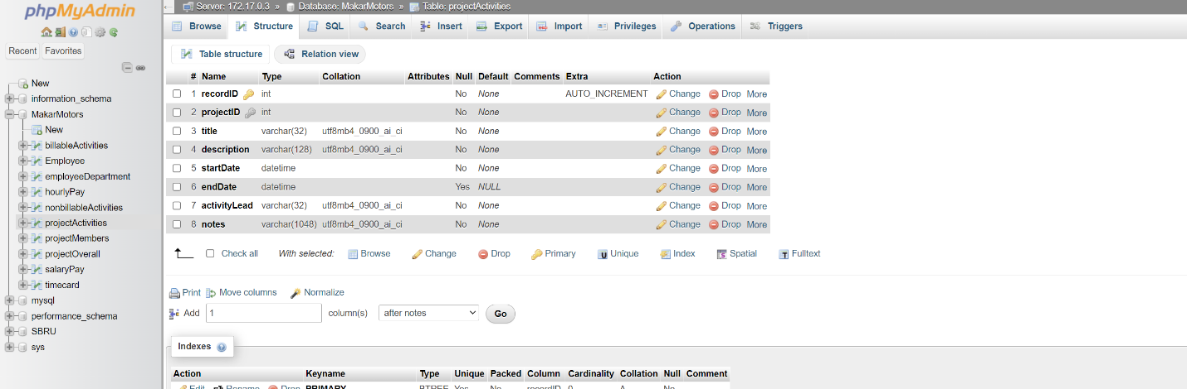

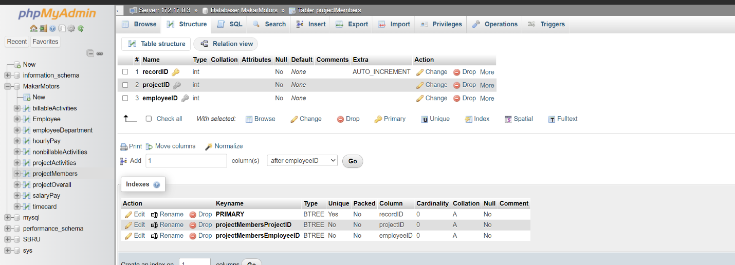

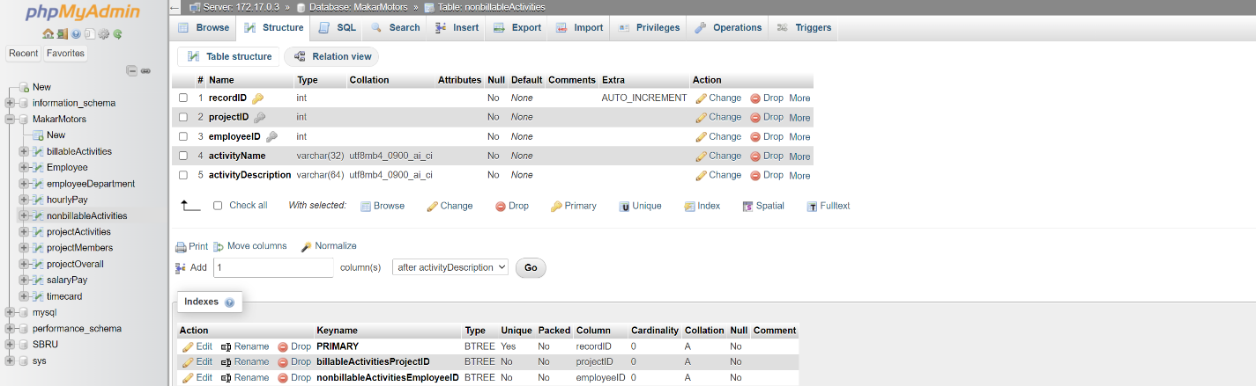

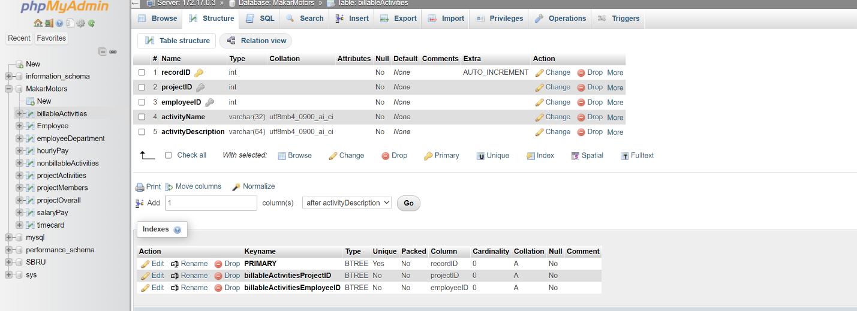

I have neither given nor received unauthorized aid in completing this work, nor have I presented someone else's work as my own.

*Dalton Murray, Norhan John*